**Assignment-2**

TOPIC: Assignment on temperature and humidity sensing and alarm automation using python

|  |  |
| --- | --- |
| Date | 23 September 2022 |
| Team ID | PNT2022TMID47161 |
| Student Register Number | 822419106901 |
| Maximum Marks | 2 Marks |

NAME: Ahilan. M

CODE:

Import random

i=2

while(True):

a=random.randint(15,89)

b=random.randint(15,89)

if(a>20 and b<57):

print("HIGH TEMPERATURE AND HUMIDITY OF:",a,b,"%", "ALARM IS ON")

elif(a<20 and b>57):

print("NORMAL TEMPERATURE AND HUMIDITY OF:",a,b,"%", "ALARM IS OFF")

if(i<20):

i=i+1

random

else:

break

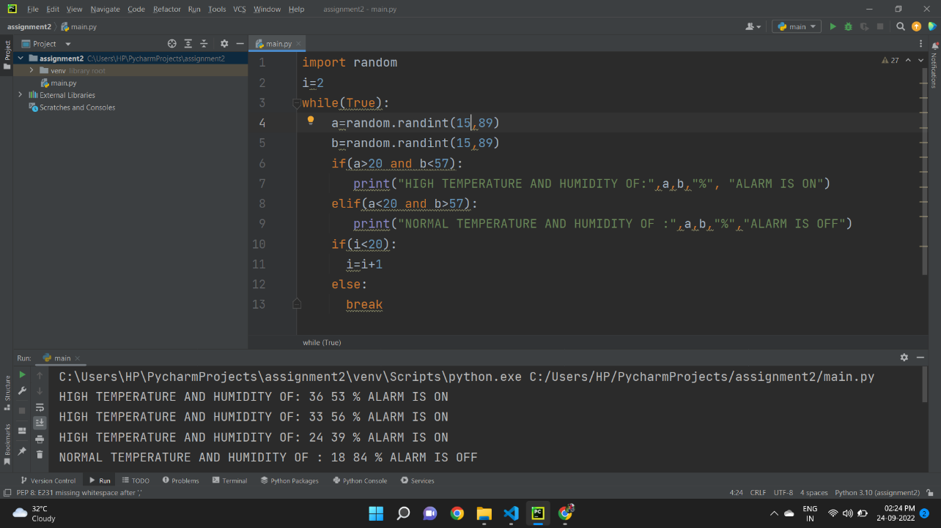

OUTPUT:

